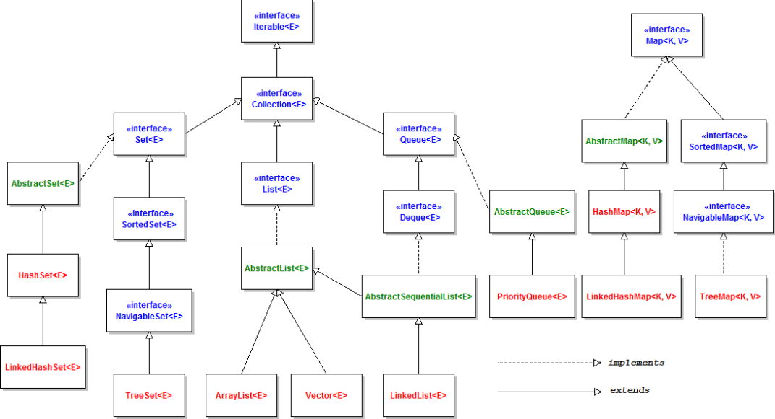

**“interface”**

**Iterator<E>**